**SIMATS SCHOOL OF ENGINEERING**

**SAVEETHA INSTITUTE OF MEDICAL AND TECHNICAL SCIENCES**

**CHENNAI-602105**

# Railway Reservation System

**A CAPSTONE PROJECT REPORT**

*Submitted in the partial fulfillment for the award of the degree of*

## BACHELOROFENGINEERING

**IN**

**COMPUTER SCIENCE AND ENGINEERING**

**Submitted by**

1. **Mallika( 192211413 )**

**P.Manohar(192210723)**

**P.Navya Sri( 192210714)**

**Under the supervision of**

**Dr.K.Vivek Balaji**

**JULY-2024**

**Table of Contents**

|  |  |
| --- | --- |
| **S.NO** | **TOPICS** |
|  | **Abstract** |
| 1 | **Introduction** |
| 2 | **Project Description** |
| 3 | **Problem Description** |
| 4 | **Tool Description** |
| 5 | **Operations** |
| 6 | **Approach / Module Description / Functionalities**   1. Home page 2. Reservation 3. Booking 4. Contact 5. about |
| 7 | **Implementation** |
| 8 | **Result** |
| 9 | **Conclusion** |
|  | **References** |

**ABSTRACT**

The Railway Reservation System is designed to streamline the process of booking train tickets, making it easier for passengers to plan their journeys and for railway operators to manage reservations efficiently. This system offers a user-friendly interface with an intuitive design and responsive layout, ensuring a consistent experience across desktops, tablets, and smartphones. Key features include real-time seat availability, advance booking options, and multiple payment methods, all aimed at providing a smooth and secure booking experience. The integrated e-ticketing system reduces the need for physical tickets by sending e-tickets with QR codes directly to passengers' devices. Passengers can create profiles to save their preferences and access booking history for easy rebooking. Comprehensive train schedules and real-time status updates keep passengers informed about their journeys. The system also offers 24/7 customer support, a detailed help section, and regular promotions and discounts. Robust security measures, including data encryption and a secure payment gateway, protect transactions and personal information. Additionally, the system provides valuable analytics and reporting tools for understanding booking trends and customer preferences, helping to improve service offerings and enhance the overall travel experience.

**INTRODUCTION**

The Railway Reservation System is a cutting-edge platform designed to simplify the process of booking train tickets, enhancing convenience for passengers and efficiency for railway operators. Featuring a user-friendly interface with an intuitive and responsive design, the system ensures a seamless experience across all devices, from desktops to smartphones.

Its comprehensive functionality includes real-time seat availability, multiple payment options, and integrated e-ticketing, all aimed at providing a smooth and secure booking process.

With robust security measures and valuable analytics tools, the Railway Reservation System not only ensures secure transactions but also offers insights to improve service offerings, making it an indispensable tool for modern railway operations.

**PROJECT DESCRIPTION**

**Project Title:** Railway reservation Website

**Project Overview:** The Railway Reservation System project aims to develop a sophisticated platform that simplifies the booking process for train tickets, catering to the needs of both passengers and railway operators. This project involves designing a user-friendly interface that is intuitive and responsive, ensuring a seamless experience across all devices, including desktops, tablets, and smartphones. The system will feature real-time seat availability updates, multiple payment options, and an integrated e-ticketing system that sends QR-coded tickets directly to passengers' devices, reducing the need for physical tickets.

Additionally, passengers will be able to create profiles to save their preferences, access their booking history for easy rebooking, and receive real-time updates on train schedules and statuses. The system will include comprehensive customer support, offering 24/7 assistance via chat, email, or phone, and a detailed help section to address common queries. Regular promotions and discounts will be available, along with loyalty programs for frequent travelers.

Security is a top priority, with data encryption and a secure payment gateway ensuring all transactions and personal information are protected. The system will also provide robust analytics and reporting tools, giving railway operators insights into booking trends and customer preferences, which will help in improving service offerings and enhancing the overall travel experience. This project is designed to streamline the ticket booking process, making it more efficient and user-friendly, ultimately contributing to a better and more secure railway travel experience for all users.

**Key Objectives for Railway Reservation System:**

**Efficient Booking Process:**

-Streamlined Ticket Booking: Simplify the process of booking tickets to make it quick and hassle-free for users.

- Multiple Booking Options: Provide options for booking different types of tickets, such as one-way, round-trip, and multi-city.

**User-Friendly Interface:**

- Intuitive Navigation: Develop a straightforward and easy-to-use interface for both first-time users and frequent travelers.

- Responsive Design: Ensure the system is fully responsive and accessible across desktops, tablets, and smartphones.

**Real-Time Updates:**

- Live Seat Availability: Offer real-time updates on seat availability across different classes and trains.

- Train Schedules and Status: Provide comprehensive information on train schedules, routes, and real-time status updates.

**Secure Payment Integration:**

- Multiple Payment Methods: Support various payment options, including credit/debit cards, net banking, and digital wallets.

- Secure Transactions: Implement robust security measures, such as data encryption and secure payment gateways, to protect user information and transactions.

**E-Ticketing:**

- Paperless Tickets: Issue e-tickets directly to passengers' email or mobile devices to reduce the need for physical tickets.

- QR Code Integration: Include QR codes in e-tickets for quick and easy verification at stations.

**Customer Profile Management:**

-User Profiles: Allow passengers to create profiles to save preferences and frequent travel details.

- Booking History: Provide access to past booking details for easy reference and rebooking.

**Comprehensive Customer Support:**

- 24/7 Assistance: Offer round-the-clock customer support through various channels, including chat, email, and phone.

- FAQs and Help Section: Include a detailed help section with answers to common questions and step-by-step guides.

**Promotions and Discounts:**

- Special Offers: Regularly update passengers on promotional fares and discounts.

- Loyalty Programs: Introduce rewards and benefits for frequent travelers to encourage repeat business.

**Robust Analytics and Reporting:**

- Sales Reports: Provide detailed insights into booking trends and revenue generation.

- Customer Preferences**: Use analytics to understand passenger preferences and improve service offerings.

**Deployment and Maintenance:**

- Reliable Hosting: Deploy the system on a reliable hosting platform to ensure high availability and performance.

- Post-Launch Support: Offer ongoing technical support and regular updates to keep the system functional and up-to-date.

- User Feedback: Continuously gather user feedback to make improvements and ensure the system meets passenger needs.

These objectives aim to create a comprehensive, secure, and user-friendly Railway Reservation System that enhances the overall travel experience for passengers while providing valuable tools and insights for railway operators.

**PROBLEM DESCRIPTION**

Problem Description for Railway Reservation System

Key Problems to Address:

Complexity of Ticket Booking:

- User Challenges: Passengers often find the existing ticket booking systems complex and difficult to navigate.

- Need for Simplification: There is a necessity for a more straightforward process that allows users to book tickets with minimal effort and technical knowledge.

Real-Time Information:

- Lack of Real-Time Updates: Current systems may not provide timely updates on seat availability, train schedules, and status, leading to confusion and inconvenience.

- Requirement for Real-Time Data: The system should offer live updates to ensure passengers have the most accurate information for their travel plans.

Secure Payment Integration:

- Payment Processing Issues: Many existing systems face challenges with secure and diverse payment options.

- Need for Secure Transactions: The system must integrate secure payment gateways and support multiple payment methods to facilitate smooth and safe transactions.

E-Ticketing and Verification:

- Physical Ticket Dependence: Reliance on physical tickets can be inconvenient and prone to loss or damage.

- Digital Solutions: There is a need for an efficient e-ticketing system with QR code verification to simplify the boarding process and reduce reliance on physical tickets.

Responsive and Accessible Design:

- Device Compatibility Issues: Current systems may not offer a consistent user experience across various devices.

- Responsive Design Requirement: The system should be fully responsive and accessible, ensuring a seamless experience on desktops, tablets, and smartphones.

Comprehensive Customer Support:

- Limited Support Options: Existing systems may not provide adequate customer support channels.

- Enhanced Support Services: The system must offer 24/7 customer support through various channels, including chat, email, and phone, to address user queries and issues promptly.

Promotions and Loyalty Programs:

- Lack of Promotional Features: Current systems may not effectively promote special offers or loyalty programs.

- Incorporating Promotions: The system should regularly update passengers on promotional fares, discounts, and loyalty rewards to encourage repeat business and enhance customer satisfaction.

Analytics and Insights:

- Data Analysis Limitations: Many systems lack robust tools for analyzing booking trends and customer preferences.

- Need for Analytics Tools: The system should provide comprehensive analytics and reporting tools to offer insights into sales performance, customer behavior, and operational efficiency.

Deployment and Maintenance:

- Operational Challenges: Ensuring consistent performance and availability of the system can be challenging.

-Reliable Hosting and Support: The system should be deployed on a reliable hosting platform, with ongoing technical support and regular updates to maintain functionality and performance.

By addressing these key problems, the Railway Reservation System aims to create an efficient, user-friendly, and secure platform that enhances the overall travel experience for passengers while providing valuable tools and insights for railway operators.

**TOOL DESCRIPTION**

**User Interface:**

**Dashboard:**

- Central Hub: A central hub for managing all aspects of the railway reservation system.

- Key Metrics Overview: Provides an overview of key metrics such as bookings, cancellations, and user activity.

- Quick Access: Quick access to various tools and settings for efficient management.

**User-Friendly Booking Interface:**

- Intuitive Navigation: Design a straightforward and intuitive interface that allows users to easily navigate and manage their bookings.

- Real-Time Availability: Display real-time seat availability and train schedules.

- Booking Process: Simplified step-by-step booking process with clear instructions and progress indicators.

**Template Library:**

- Customizable Templates: A collection of professionally designed, customizable templates for the booking interface and user profiles.

- Category-Based Templates: Templates categorized based on different user needs (e.g., frequent travelers, occasional users).

- Easy Template Switching: Easy switching between templates with data preservation.

**Responsive Design:**

- Multi-Device Compatibility: Ensures the system looks and functions well on all devices, including desktops, tablets, and smartphones.

- Preview Tools: Built-in tools to preview and adjust the interface for different screen sizes.

**Tools and Technologies:**

- HTML/CSS: For creating the structure and styling of the interface.

**Marketing and SEO Tools:**

-SEO Optimization: Tools for optimizing the system content for search engines, including meta tags and keywords.

-Email Marketing: Integration with email marketing services for sending booking confirmations and promotional campaigns.

-Social Media Integration: Easy sharing of travel plans and bookings on social media platforms, with engagement tracking.

**Operations:**

**Customizations**

- Template Selection and Customization: Users can choose and customize templates.

- Drag-and-Drop Interface: Use JavaScript frameworks (like React, Vue, or Angular) for a user-friendly drag-and-drop interface.

- Real-Time Preview: Implement real-time preview using WebSocket or AJAX for live updates.

**Booking and E-Ticketing Integration**

- Tools and Technologies:

- Payment Gateways (e.g., Stripe, PayPal): For handling transactions.

- Booking Management Libraries: For managing the booking process.

- Operations:

- Ticket Booking: Using a backend (Node.js, Django, or Ruby on Rails) for CRUD operations on bookings.

- Payment Processing: Integrating APIs from payment gateways to handle transactions securely.

- E-Ticket Generation: Building backend logic to generate and send e-tickets with QR codes for verification.

**Inventory Management**

- Tools and Technologies:

- Database Management (e.g., MongoDB, MySQL): For storing booking and train data.

- Server-Side Scripting (e.g., Node.js, Python): For handling inventory logic.

**- Operations:**

- Seat Availability Monitoring: Implementing server-side scripts to monitor seat availability and update in real-time.

- Automated Alerts: Setting up automated systems to alert users about seat availability and booking confirmations.

**Customer Engagement**

- Tools and Technologies:

- Email APIs (e.g., SendGrid, Mailchimp): For email marketing campaigns.

- Social Media APIs (e.g., Facebook, Twitter): For social media integration.

- Live Chat Tools (e.g., Intercom, Tawk.to): For real-time customer support.

**- Operations:**

- Email Campaigns: Using email APIs to send booking confirmations, newsletters, and promotional emails.

- Social Media Integration: Utilizing social media APIs to share travel plans and updates directly from the system.

- Customer Reviews and Ratings: Implementing user feedback forms and displaying reviews using JavaScript and server-side scripting.

**Analytics and Reporting**

**- Tools and Technologies:**

- Google Analytics: For tracking system traffic and user behavior.

- Custom Analytics Dashboards: Built using JavaScript libraries like Chart.js or D3.js.

**- Operations:**

- Booking Analytics: Using server-side scripting to aggregate booking data and visualize it on custom dashboards.

- User Behavior Tracking: Integrating Google Analytics to monitor user interactions and generate insights.

- Performance Reports: Automated generation of reports on system performance, bookings, and user engagement.

**Security and Compliance**

- Tools and Technologies:

- SSL Certificates: For secure data transmission.

- Data Protection Tools: For ensuring compliance with regulations like GDPR.

- Operations:

- User Authentication: Implementing secure login systems using OAuth or JWT.

- Data Encryption: Using HTTPS and encrypting sensitive data in the database.

- Compliance Monitoring: Regularly auditing the system for compliance with data protection regulations.

**Approach / Module Description / Functionalities**

- **Homepage**: to reserve a ticket.

-**Reserve ticket**:Consist of passenger name,age ,email,destination,departure and date.

-**Reservation Details**: Present the list of the details given in the reserve ticket page.

- **Contact Us**: Provides email, details, and phone number for user support and inquiries.

**-About Us:**Consist about the ceo,sto etc….

This comprehensive plan for the Railway Reservation System aims to address key challenges, enhance user experience, and provide valuable tools and insights for efficient management and improved customer satisfaction.

**IMPLEMENTATION**

**Homepage:**

|  |
| --- |
| <!DOCTYPE html>  <html lang="en">  <head>      <meta charset="UTF-8">      <meta name="viewport" content="width=device-width, initial-scale=1.0">      <title>Train Ticket Reservation System</title>      <style>          body {              font-family: Arial, sans-serif;              background-color: #f4f4f4;              margin: 0;              padding: 0;          }          .header {              background-color: #333;              color: white;              padding: 10px 0;              text-align: center;              background-image: url('header-bg.jpg'); /* Replace with your image URL */              background-size: cover;              background-position: center;          }          .header img {              width: 100px; /* Adjust size as needed */              vertical-align: middle;          }          .nav {              background-color: #444;              overflow: hidden;          }          .nav a {              float: left;              display: block;              color: white;              text-align: center;              padding: 14px 16px;              text-decoration**: none;**          }          .nav a:hover {              background-color: #ddd;              color: black;          }          .container {              width: 80%;              margin: 20px auto;              background-color: #fff;              padding: 20px;              box-shadow: 0 0 10px rgba(0,0,0,0.1);              text-align: center;          }          .welcome img {              width: 100%; /* Adjust size as needed */              max-width: 600px;              height: auto;          }          .welcome h2 {              margin-top: 0;          }          .start-button {              margin-top: 20px;          }          .start-button a {              background-color: #5cb85c;              color: white;              padding: 10px 20px;              text-decoration: none;              border-radius: 4px;              font-size: 16px;          }          .start-button a:hover {              background-color: #4cae4c;          }      </style>  </head>  <body>      <div class="header">          <img src="C:\Users\malli\Desktop\train ticket\logo.jpg" alt="logo"> <!-- Replace with your logo image -->          <h1>Train Ticket Reservation System</h1>      </div>      <div class="nav">          <a href="homepage.html">Home</a>          <a href="reservation.html">Reserve Ticket</a>          <a href="book.html">Reservation Details</a>          <a href="contact.html">Contact Us</a>          <a href="about.html">About Us</a>      </div>      <div class="container">          <div class="welcome">              <h2>Welcome to the Train Ticket Reservation System</h2>              <img src="C:\Users\malli\Desktop\train ticket\trains.avif" alt="trains"> <!-- Replace with your train image -->              <p>Book your train tickets easily and conveniently.</p>          </div>          <div class="start-button">              <a href="reservation.html">Start Reservation</a>          </div>      </div>  </body>  </html> |
| RESERVATION.HTML:  <!DOCTYPE html>  <html lang="en">  <head>      <meta charset="UTF-8">      <meta name="viewport" content="width=device-width, initial-scale=1.0">      <title>Train Ticket Reservation</title>      <style>          body {              font-family: Arial, sans-serif;              background-color: #f4f4f4;              margin: 0;              padding: 0;          }          .header {              background-color: #333;              color: white;              padding: 10px 0;              text-align: center;              position: relative;          }          .header img {              width: 100px;              height: auto;              position: absolute;              top: 50%;              left: 20px;              transform: translateY(-50%);          }          .nav {              background-color: #444;              overflow: hidden;          }          .nav a {              float: left;              display: block;              color: white;              text-align: center;              padding: 14px 16px;              text-decoration: none;          }          .nav a:hover {              background-color: #ddd;              color: black;          }          .container {              width: 80%;              margin: 20px auto;              background-color: #fff;              padding: 20px;              box-shadow: 0 0 10px rgba(0,0,0,0.1);          }          h1 {              text-align: center;              color: #333;          }          .section-image {              width: 100%;              height: auto;              margin-top: 20px;              border-radius: 8px;          }          form {              display: flex;              flex-direction: column;          }          label {              margin-top: 10px;              font-weight: bold;              display: flex;              align-items: center;          }          label img {              margin-right: 10px;          }          input, select {              padding: 10px;              margin-top: 5px;              margin-bottom: 10px;              border: 1px solid #ccc;              border-radius: 4px;          }          button {              padding: 10px;              background-color: #5cb85c;              color: white;              border: none;              border-radius: 4px;              cursor: pointer;          }          button:hover {              background-color: #4cae4c;          }          .illustrative-image {              width: 100%;              height: auto;              margin-top: 20px;              border-radius: 8px;          }      </style>  </head>  <body>      <div class="header">          <img src="C:\Users\malli\Desktop\train ticket\logo.jpg" alt="logo">          <h1>Train Ticket Reservation System</h1>      </div>      <div class="nav">          <a href="homepage.html">Home</a>          <a href="reservation.html">Reserve Ticket</a>          <a href="book.html">Reservation Details</a>          <a href="contact.html">Contact Us</a>          <a href="about.html">About Us</a>      </div>      <div class="container">          <h1>Reserve Your Ticket</h1>          <form action="book.html" method="post">              <label for="departure">                  <img src="C:\Users\malli\Desktop\train ticket\Departure.jpg" alt="Departure" width="20">                  Departure Station:              </label>              <select id="departure" name="departure" required>                  <option value="">Select Departure Station</option>                  <option value="Station A">Station A</option>                  <option value="Station B">Station B</option>                  <option value="Station C">Station C</option>              </select>              <label for="destination">                  <img src="C:\Users\malli\Desktop\train ticket\destination.png" alt="destination" width="20">                  Destination Station:              </label>              <select id="destination" name="destination" required>                  <option value="">Select Destination Station</option>                  <option value="Station A">Station A</option>                  <option value="Station B">Station B</option>                  <option value="Station C">Station C</option>              </select>              <label for="travel-date">                  <img src="C:\Users\malli\Desktop\train ticket\date.png" alt="date" width="20">                  Travel Date:              </label>              <input type="date" id="travel-date" name="travel_date" required>              <label for="passenger-name">                  <img src="C:\Users\malli\Desktop\train ticket\passenger.png" alt="passenger" width="20">                  Passenger Name:              </label>              <input type="text" id="passenger-name" name="passenger_name" placeholder="Enter your name" required>              <label for="passenger-age">                  <img src="C:\Users\malli\Desktop\train ticket\age.png" alt="age" width="20">                  Passenger Age:              </label>              <input type="number" id="passenger-age" name="passenger_age" placeholder="Enter your age" required>              <label for="email">                  <img src="C:\Users\malli\Desktop\train ticket\email.jpg" alt="email" width="20">                  Email Address:              </label>              <input type="email" id="email" name="email" placeholder="Enter your email" required>              <button type="submit">Reserve Ticket</button>          </form>      </div>  </body>  </html> |
| RESERVATION DETAILS.HTML:  <!DOCTYPE html>  <html lang="en">  <head>      <meta charset="UTF-8">      <meta name="viewport" content="width=device-width, initial-scale=1.0">      <title>Reservation Details</title>      <style>          body {              font-family: Arial, sans-serif;              background-color: #f4f4f4;              margin: 0;              padding: 0;          }          .header {              background-color: #333;              color: white;              padding: 10px 0;              text-align: center;          }          .nav {              background-color: #444;              overflow: hidden;          }          .nav a {              float: left;              display: block;              color: white;              text-align: center;              padding: 14px 16px;              text-decoration: none;          }          .nav a:hover {              background-color: #ddd;              color: black;          }          .container {              width: 80%;              margin: 20px auto;              background-color: #fff;              padding: 20px;              box-shadow: 0 0 10px rgba(0,0,0,0.1);          }          h1 {              text-align: center;              color: #333;          }          ul {              list-style-type: none;              padding: 0;          }          li {              background-color: #f4f4f4;              margin: 5px 0;              padding: 10px;              border: 1px solid #ddd;              border-radius: 4px;          }          .next-link {              text-align: center;              margin-top: 20px;          }          .next-link a {              color: #5cb85c;              text-decoration: none;              font-weight: bold;          }          .next-link a:hover {              text-decoration: underline;          }      </style>  </head>  <body>      <div class="header">          <h1>Train Ticket Reservation System</h1>      </div>      <div class="nav">          <a href="homepage.html">Home</a>          <a href="reservation.html">Reserve Ticket</a>          <a href="book.html">Reservation Details</a>          <a href="contact.html">Contact Us</a>          <a href="about.html">About Us</a>      </div>      <div class="container">          <h1>Reservation Details</h1>          <p>Thank you for booking with us!</p>          <p>Here are the details of your reservation:</p>          <ul>              <li><strong>Departure Station:</strong> [Departure Station]</li>              <li><strong>Destination Station:</strong> [Destination Station]</li>              <li><strong>Travel Date:</strong> [Travel Date]</li>              <li><strong>Passenger Name:</strong> [Passenger Name]</li>              <li><strong>Passenger Age:</strong> [Passenger Age]</li>              <li><strong>Email Address:</strong> [Email Address]</li>          </ul>          <div class="next-link">              <a href="contact.html">Proceed to Next Page</a>          </div>      </div>  </body>  </html> |
| CONTACT.HTML:  <!DOCTYPE html>  <html lang="en">  <head>      <meta charset="UTF-8">      <meta name="viewport" content="width=device-width, initial-scale=1.0">      <title>Contact Us</title>      <style>          body {              font-family: Arial, sans-serif;              background-color: #f4f4f4;              margin: 0;              padding: 0;          }          .header {              background-color: #333;              color: white;              padding: 10px 0;              text-align: center;              position: relative;          }          .header img {              width: 100px;              height: auto;              position: absolute;              top: 50%;              left: 20px;              transform: translateY(-50%);          }          .nav {              background-color: #444;              overflow: hidden;          }          .nav a {              float: left;              display: block;              color: white;              text-align: center;              padding: 14px 16px;              text-decoration: none;          }          .nav a:hover {              background-color: #ddd;              color: black;          }          .container {              width: 80%;              margin: 20px auto;              background-color: #fff;              padding: 20px;              box-shadow: 0 0 10px rgba(0,0,0,0.1);              display: flex;              flex-direction: row;              flex-wrap: wrap;          }          .container > div {              flex: 1;              margin: 10px;          }          .container img {              width: 100%;              border-radius: 8px;          }          h1 {              text-align: center;              color: #333;          }          form {              display: flex;              flex-direction: column;          }          label {              margin-top: 10px;              font-weight: bold;          }          input, textarea {              padding: 10px;              margin-top: 5px;              margin-bottom: 10px;              border: 1px solid #ccc;              border-radius: 4px;          }          button {              padding: 10px;              background-color: #5cb85c;              color: white;              border: none;              border-radius: 4px;              cursor: pointer;          }          button:hover {              background-color: #4cae4c;          }          .contact-info {              background-color: #e7e7e7;              padding: 20px;              border-radius: 8px;              text-align: center;          }          .map {              border-radius: 8px;              overflow: hidden;          }      </style>  </head>  <body>      <div class="header">          <img src="C:\Users\malli\Desktop\train ticket\logo.jpg" alt="logo">          <h1>Train Ticket Reservation System</h1>      </div>      <div class="nav">          <a href="homepage.html">Home</a>          <a href="reservation.html">Reserve Ticket</a>          <a href="book.html">Reservation Details</a>          <a href="contact.html">Contact Us</a>          <a href="about.html">About Us</a>      </div>      <div class="container">          <div>              <h1>Contact Us</h1>              <form action="about.html" method="post">                  <label for="name">Name:</label>                  <input type="text" id="name" name="name" placeholder="Enter your name" required>                  <label for="email">Email:</label>                  <input type="email" id="email" name="email" placeholder="Enter your email" required>                  <label for="message">Message:</label>                  <textarea id="message" name="message" rows="5" placeholder="Enter your message" required></textarea>                  <button type="submit">Submit</button>              </form>          </div>          <div>              <div class="contact-info">                  <h2>Our Office</h2>                  <p>thiruvallur Train Street, chennai, Tamilnadu</p>                  <p>Email: mallikareddy@traintickets.com</p>                  <p>Phone: +91 8573905723</p>              </div>          </div>      </div>  </body>  </html> |
| ABOUT.HTML:  <!DOCTYPE html>  <html lang="en">  <head>      <meta charset="UTF-8">      <meta name="viewport" content="width=device-width, initial-scale=1.0">      <title>About Us</title>      <style>          body {              font-family: Arial, sans-serif;              background-color: #f4f4f4;              margin: 0;              padding: 0;          }          .header {              background-color: #333;              color: white;              padding: 10px 0;              text-align: center;          }          .nav {              background-color: #444;              overflow: hidden;          }          .nav a {              float: left;              display: block;              color: white;              text-align: center;              padding: 14px 16px;              text-decoration: none;          }          .nav a:hover {              background-color: #ddd;              color: black;          }          .container {              width: 80%;              margin: 20px auto;              background-color: #fff;              padding: 20px;              box-shadow: 0 0 10px rgba(0,0,0,0.1);          }          h1, h2 {              text-align: center;              color: #333;          }          p {              line-height: 1.6;          }          .team {              display: flex;              flex-wrap: wrap;              justify-content: space-around;          }          .team-member {              flex: 1 1 30%;              margin: 10px;              padding: 10px;              background-color: #f9f9f9;              border-radius: 8px;              text-align: center;          }      </style>  </head>  <body>      <div class="header">          <h1>Train Ticket Reservation System</h1>      </div>      <div class="nav">          <a href="homepage.html">Home</a>          <a href="reservation.html">Reserve Ticket</a>          <a href="book.html">Reservation Details</a>          <a href="contact.html">Contact Us</a>          <a href="about.html">About Us</a>      </div>      <div class="container">          <h1>About Us</h1>          <p>Welcome to the Train Ticket Reservation System. We are dedicated to providing a seamless and convenient way for you to book your train tickets online. Our system allows you to easily select your departure and destination stations, choose your travel dates, and enter your passenger details, all from the comfort of your home.</p>          <p>We aim to make your train travel experience as smooth and enjoyable as possible. If you have any questions or need assistance, please feel free to <a href="contact.html">contact us</a>.</p>            <h2>Our Mission</h2>          <p>Our mission is to revolutionize the way people book train tickets by offering a user-friendly, efficient, and reliable platform. We strive to provide the best customer service and continuously improve our system to meet the needs of our users.</p>            <h2>Meet the Team</h2>          <div class="team">              <div class="team-member">                  <h3>John Doe</h3>                  <p>CEO</p>              </div>              <div class="team-member">                  <h3>Jane Smith</h3>                  <p>CTO</p>              </div>              <div class="team-member">                  <h3>Emily Johnson</h3>                  <p>COO</p>              </div>          </div>            <p>Thank you for choosing our service!</p>      </div>  </body>  </html> |

**8. Result:**

Homepage.html-

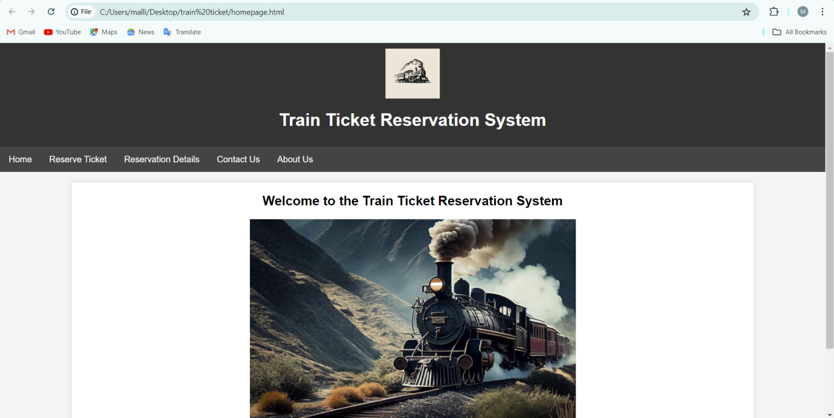

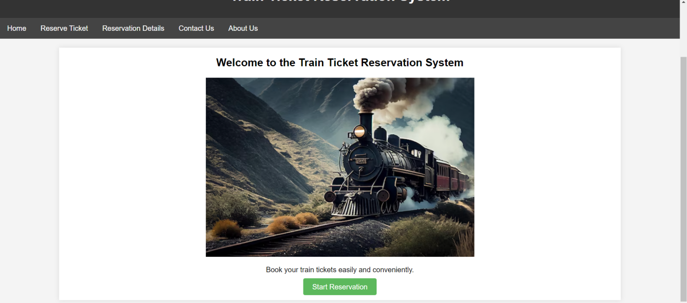

**REAERVATION.HTML:**

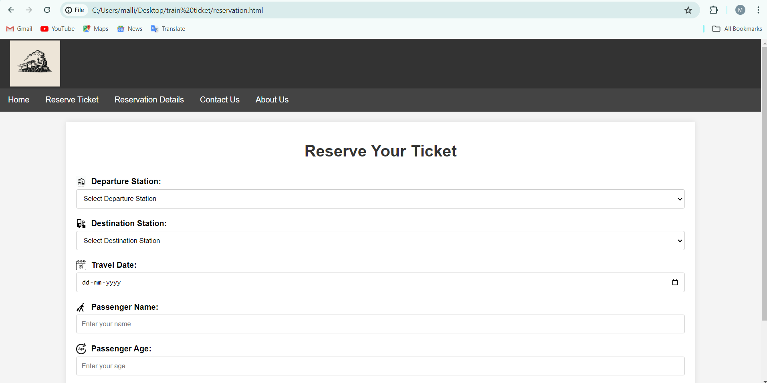

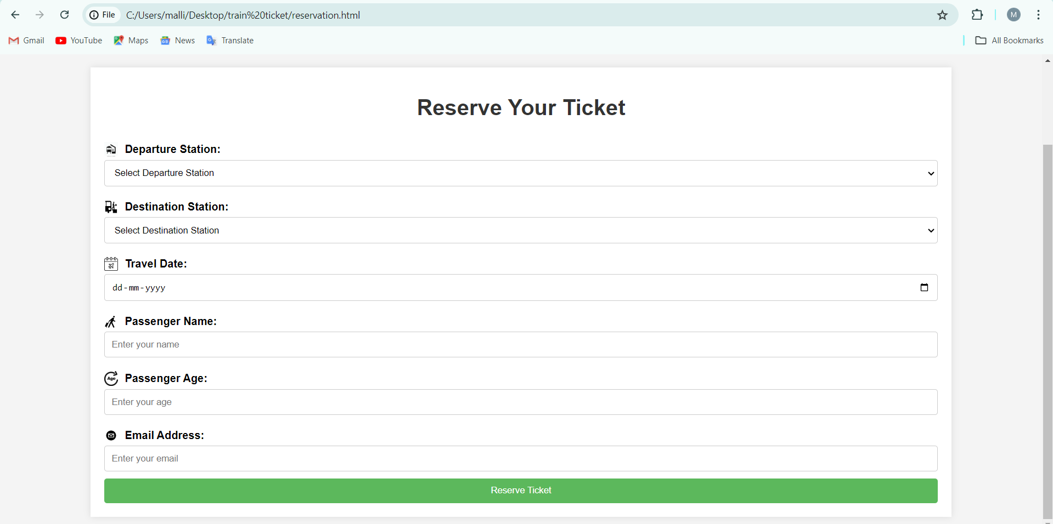

**RESERVATION DETAILS:**

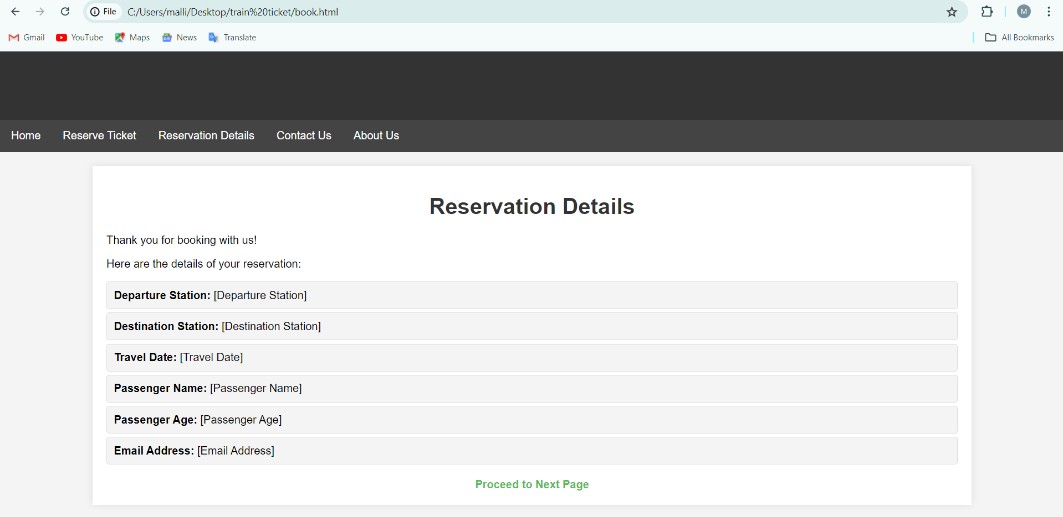

**CONTACT US:**

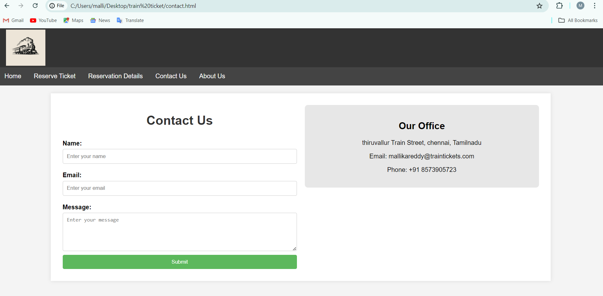

**ABOUT US:**

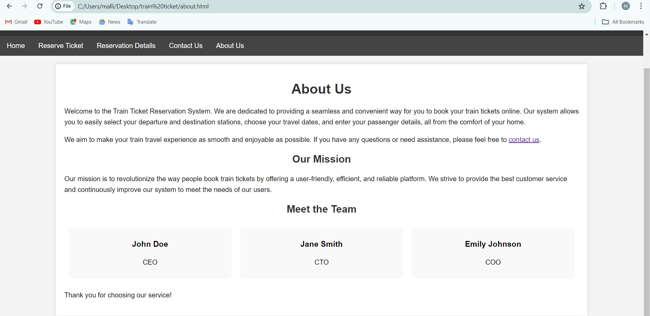

**CONCLUSION**

The Railway Reservation System is designed to address key challenges in the current booking landscape by providing a streamlined, user-friendly platform that enhances the overall travel experience. By focusing on simplicity and efficiency, the system aims to make the ticket booking process accessible to all users, regardless of their technical expertise. Real-time updates, secure payment integration, and an intuitive interface are central to ensuring a smooth and reliable service.

The system's responsive design guarantees a seamless experience across all devices, while its advanced features—such as e-ticketing, comprehensive customer support, and robust analytics—empower both passengers and railway operators. By integrating social media and marketing tools, the system also helps railway companies expand their reach and engage with a broader audience.

**REFERENCES**

1. [MDN](https://developer.mozilla.org/) [Web](https://developer.mozilla.org/) [Docs](https://developer.mozilla.org/)
2. [W3Schools](https://www.w3schools.com/)

3. [Bootstrap](https://getbootstrap.com/)

1. [CSS](https://css-tricks.com/) [Tricks](https://css-tricks.com/)
2. [Shopify](https://www.shopify.com/)
3. *GeeksforGeeks*